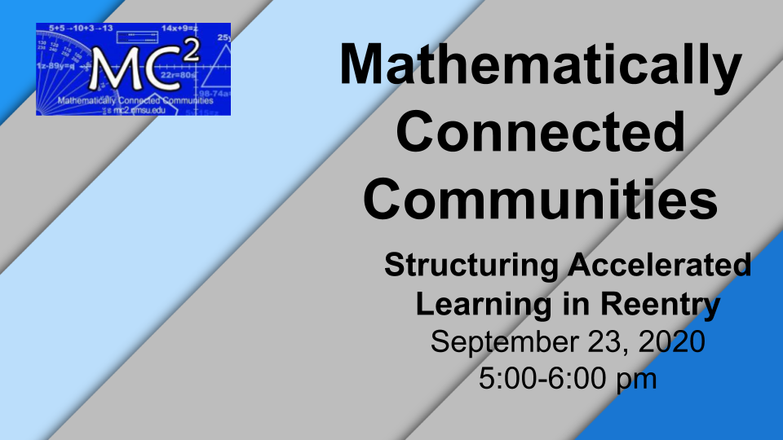
Please note, this is a shared document and many of these links are shared documents. To edit or make changes, please make a copy of this page or a specific resource or download it into a program of your choice. See the second page with instructions on how to do this.

Link to Slideshow: Participant Copy of Session 4 Facilitator Slides Purposeful Reentry

Session Specific Links/Additional Resources and Links

NM PED Instructional Acceleration Guidance, 1 page: https://drive.google.com/file/d/1ZZMvEmmAAIhbbYK7KbfSqApDyu-e2VPv/view?usp=sharing

Link to virtual Cuisenaire Rods: https://mathsbot.com/manipulatives/rods

Link to Google Doc with Instructions: https://docs.google.com/document/d/1n_TM3IobzhF-KoUSmG5nnvcRwU_d8ZNNYbIflMfGLBw/edit?usp=sharing

Link to NM PED Website: https://webnew.ped.state.nm.us/
Link to Achieve the Core Priority Instructional Content for both Math/ELA K-8 and HS: https://achievethecore.org/page/3267/2020-21-priority-instructional-content-in-english-language-arts-literacy-and-mathematics

Link to MC² Website: https://mc2.nmsu.edu/
Link to MC² Professional Learning: https://mc2.nmsu.edu/pd/
Link to MC² Contact Page: https://mc2.nmsu.edu/about-us/contact-us/

Thank you for your work and dedication to New Mexico students and families!

Make a Copy or Download a Shared File

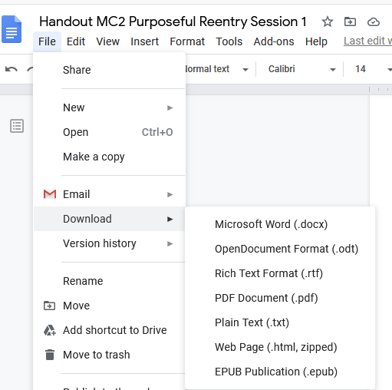

To make a copy, go to File, Make a Copy, and then rename the copied file. Your copy will be in your Shared With Me folder in your Google Drive.

To download it into another program, go to File, Download, and select the program you would like to use and then save it in that program.

